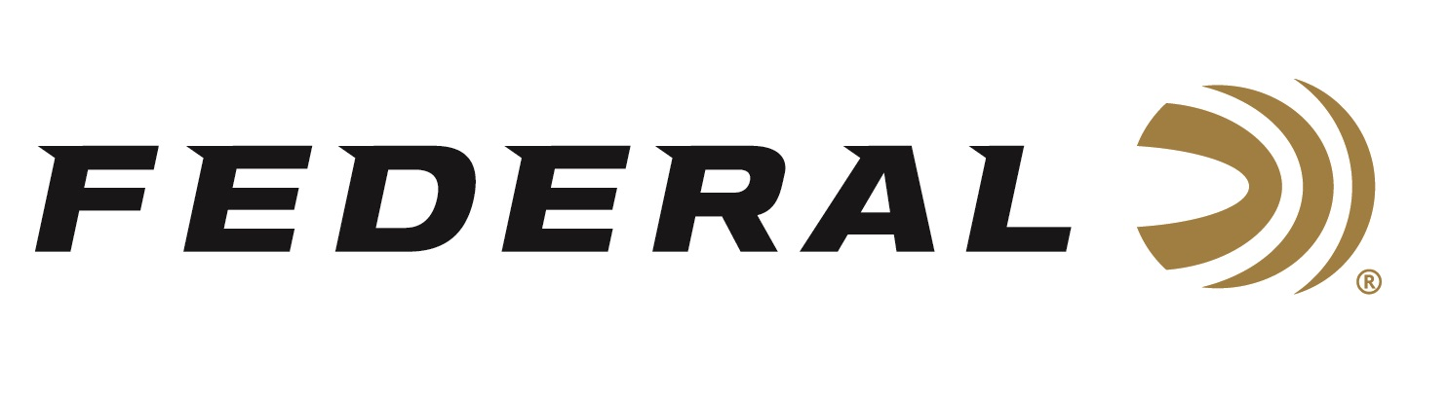

FOR IMMEDIATE RELEASE

**Federal Launches Personal Defense Deals Rebate Program**

**ANOKA, Minnesota – June 27, 2025** — Federal Ammunition has announced a new rebate program for customers purchasing select Federal Premium® Personal Defense handgun ammunition. The Personal Defense Deals rebate runs July 1 through July 31, 2025, giving customers the chance to earn up to $200 back.

“With this limited-time promotion, concealed carry holders and home defenders can stock up on some of our most trusted Personal Defense loads while also saving money,” said Federal’s Director of Trade Marketing, Jill Karolewski. “This rebate is a great opportunity for anyone serious about protecting what matters most.”

To qualify, customers must purchase at least two boxes of eligible Federal Premium Personal Defense handgun ammunition and will receive a rebate of 20 percent of the purchase price, with a maximum rebate of $200 per person or household.

Qualifying handgun products are limited to HST, Hydra-Shok, Hydra-Shok Deep, Practice & Defend, HST Micro, and Hydra-Shok Low Recoil.

Valid purchases must be made between July 1 and July 31, 2025. Rebate submissions must be received by August 31, 2025. Only select products are eligible—see official terms and conditions for full details.

For complete rebate details, visit: <https://www.federalpremium.com/this-is-federal/rebates-and-promotions.html>

Federal Ammunition products are available at dealers nationwide and online. For more information on all Federal products and to sign up for notifications about new product availability, rebate promotions, and other brand news via email, visit [www.federalpremium.com](http://www.federalpremium.com).

**Press Release Contact:**  
JJ Reich  
Senior Manager – Press Relations  
E-mail: [media@tkghunt.com](mailto:media@tkghunt.com)

**About Federal Ammunition**

Federal, headquartered in Anoka, MN, is an ammunition brand of The Kinetic Group, owned by CSG, a globally diversified industrial group based in Prague, Czech Republic. Since 1922, Federal has been a leader in ammunition innovation, delivering high-quality sporting and hunting products to shooters worldwide. With a commitment to conservation and the outdoor community, Federal continues to manufacture industry-leading ammunition that enhances the shooting experience while supporting outdoor traditions.